**Digital Clock and Date App**

*A working clock and date app using html, css, and javascript*

Click [here](https://nomoneyrecord.github.io/Digital-Clock-App/) to see the website

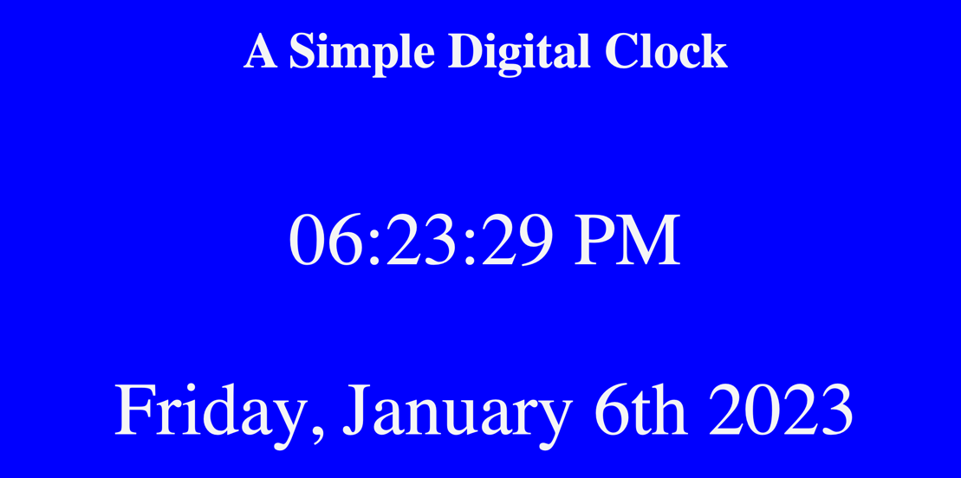

**Summary**

This app was the first experience I’ve had with utilizing HTML, CSS, and JavaScript. This taught me a lot about utilizing functions, values, parameters, methods, and gaining a better understanding about JavaScript as an object orientated and verbose language for functionality. Ran into a lot of concepts with JavaScript that I couldn’t grasp until I kept experimenting with multiple techniques and eventually catching on to the syntax and structure of the language. It was very exciting once I started to see the results of my work and finalizing the deliverables of the application. I also utilized Chat GPT to give me a code recommendation to get the background to shift colors. I don’t fully understand the CSS of this result but it introduced me to some new commands for styling.

**Author**

* **Gary Hughes Jr** – *Full-Stack Software Developer -* [Website](http://127.0.0.1:5500/index.html) | [LinkedIn](https://www.linkedin.com/in/gary-hughes-jr-64925b229/)